**Configure SSL on TOMCAT 7:**

Follow the below given steps to configure SSL:

* Go to Java bin directory and generate the ***keystore*** fie.

***C:\Program Files\Java\jdk1.7.0_55\bin>keytool -genkey -keystore C:\.keystore -alias tomcat -keyalg RSA***

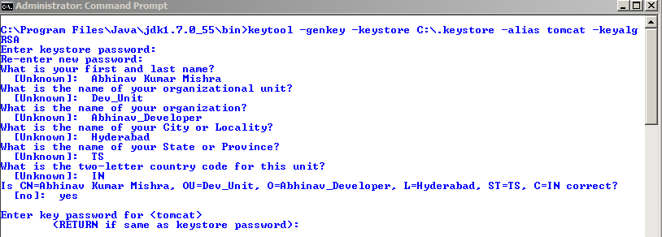

**This will generate a “.keystore” file at c:\ drive.**

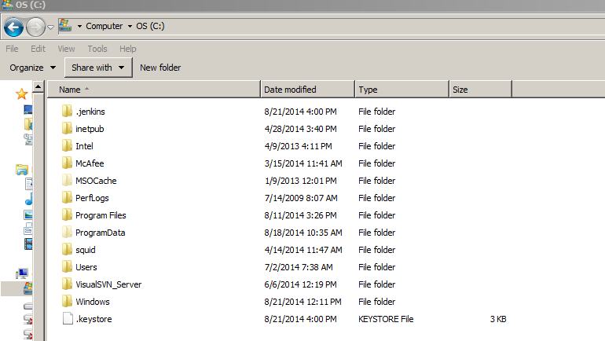

* Go Tomcat's server.xml file and uncomment the port 8443 SSL Connector that came with Tomcat.

Additionally provide the keystore location in the configuration as given below.

*<Connector*

*protocol="HTTP/1.1"*

*port="8443" maxThreads="200"*

*scheme="https" secure="true" SSLEnabled="true"*

***keystoreFile="C:/.keystore"******keystorePass="changeit"***

*clientAuth="false" sslProtocol="TLS"/>*

**Note:**

Value of ‘***keystorepass’*** should be same as the password provided during the generation of ‘***.keystore***’ file above. In my case I have provided the keystore password as ‘changeit’ while generating the keystore.

Here ***${user.home}*** *is the root drive i.e. “c:\”*

* Restart the tomcat server.
* Open [***https://localhost:8443/***](https://localhost:8443/)*URL, it will open the**tomcat manager page with SSL.*

We will receive a warning message. This is basically telling the browser user that the certificate has not been verified by a Certificate Authority. This is because we created a self-signed certificate, which encrypts the communication between browser and server but doesn't guarantee that if certificate is from trusted authority.

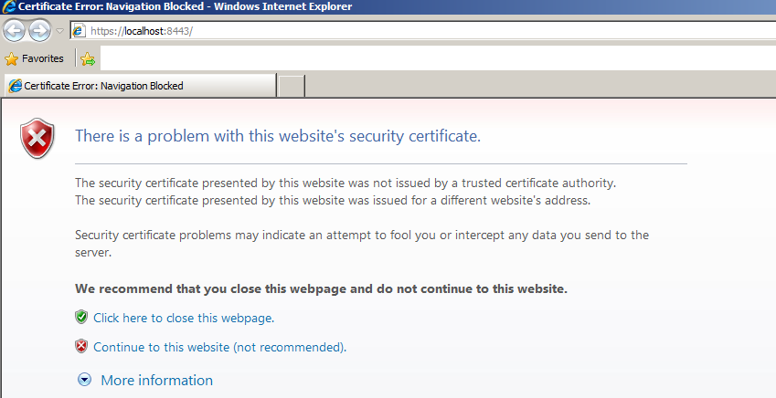

If we click to continue to the website, we can see that we indeed are able to hit are web application using SSL.

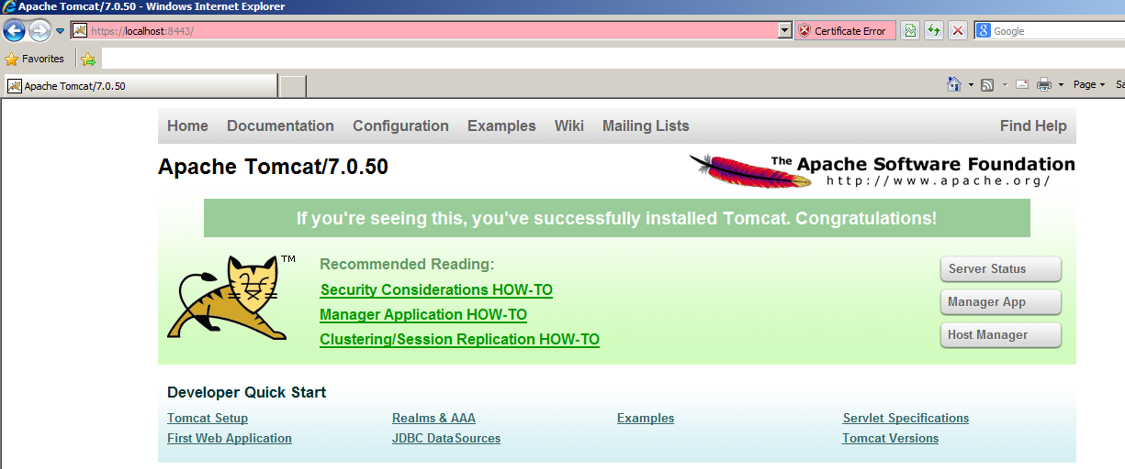

* Let's verify that communication is encrypted or not. Open Eclipse's TCP/IP Monitor view and set up monitors on port 9090 to forward to 8443 and a monitor on port 8080 to forward to 8082.
* Click on ‘Add’ button in TCP/IP monitor window in eclipse to setup monitors. Provide the inputs and Click ‘OK’ to add.

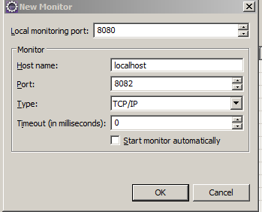

* Set the types to TCP/IP and start both monitors, and Click ‘OK’.
* Select each monitors and click on ‘Start’ to start the monitor.

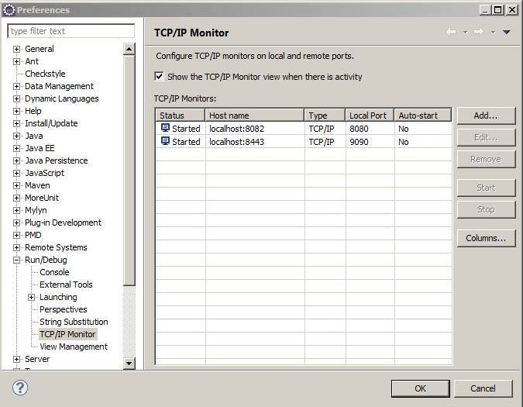

* Go to TCP/IP monitor view (*Window>Show View > TCP/IP Monitor*)

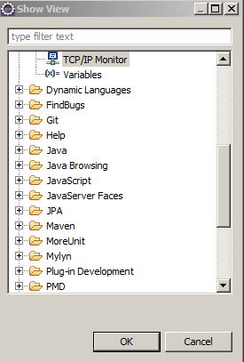

* Open the [***http://localhost:8080/DemoServlet/***](http://localhost:8080/DemoServlet/)URL and see the monitor. We can view the headers and bodies of the requests and responses. See the highlighted section.

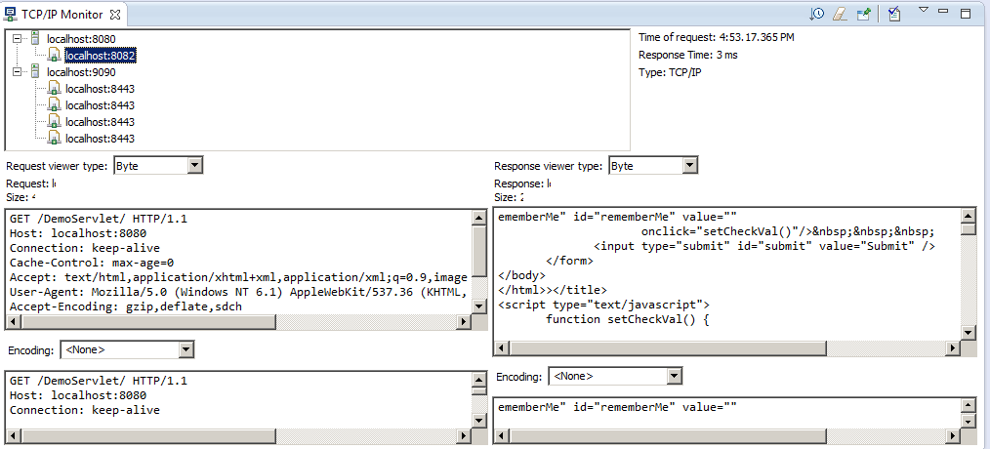

* Same way hit the [***https://localhost:9090/DemoServlet/***](https://localhost:9090/DemoServlet/)URL and see the monitor. We cannot view the headers and bodies of the requests and responses. See the highlighted section.

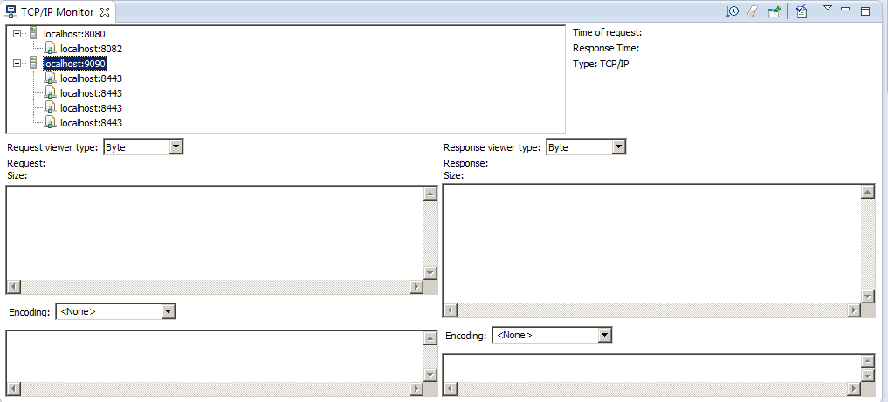

We are done ☺